

AI COURSE PROJECT

Group:

Anas Ashir (i16-0068)

Hamza Tariq (i16-0134)

Hassan Farooq (i16-0302)

Section: D

Instructor: Dr. Labiba Fahad

DoS: 8th December, 2019

**Project Overview**

This project is about TORCS - The Open Racing Car Simulator. Where the clients through a UDP connection are connected with the server which eventually allows different players to participate and play the game. The different players are actually the bots which are trained using different Artificial intelligence (AI) techniques like, rule based, Neural Networks, reinforcement learning, etc.

This project contains our client which is trained using linear regression and XG_boost, client plays the game when it gets connected through the server.

**About the Team**

The project is done using the techniques that are learned in the course of Artificial Intelligence Fall 2019 at Fast National University, Islamabad. All group members belong to same section i.e. D. All group members have contributed equally in this project.

**Techniques Used**

* **Logistic Regression**

We used logistic regression because when we look at the data features the majority of outputs are not continuous values, therefore, for such type of problems logistic regression performs better.

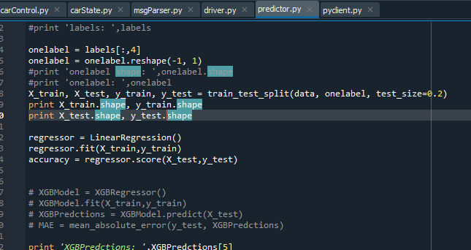

* **XGBoost**

We used XGBoost for steering only, XGBoost is actually a gradient boosting algorithm and is on the base of them decision trees are used.



**Proposed Approach**

The approach that we have used is based on the techniques that are described above. We have trained Logistic Regression and XGBoost, and finally saved the models. At run time, the vector of input features is fed to the model and the model that gives less loss value is used for outputting a features. For different output prediction we have used different models.

**Conclusion**

The following table shows the mean absolute error that we have obtained for the output features:

|  |  |
| --- | --- |
| **Output** | **Error** |
| Steering | MAE: 0.0029 |
| Acceleration | MAE: 0.0012 |
| Gear | MAE: 0.0213 |
| Focus | MAE: 0.00009 |
| Clutch | MAE: 0.00314 |